

**Artificial Intelligence and Data Science Department.**

OS / Even Sem 2021-22 / Experiment 9.

**___________________________________________________**

YASH SARANG.

47 / D6AD.

EXPERIMENT - 9.

Banker’s Algorithm.

**___________________________________________________**

**Aim:** WAP to simulate Banker’s Algorithm.

**___________________________________________________**

**Output:**



**___________________________________________________**

**Conclusion:-**

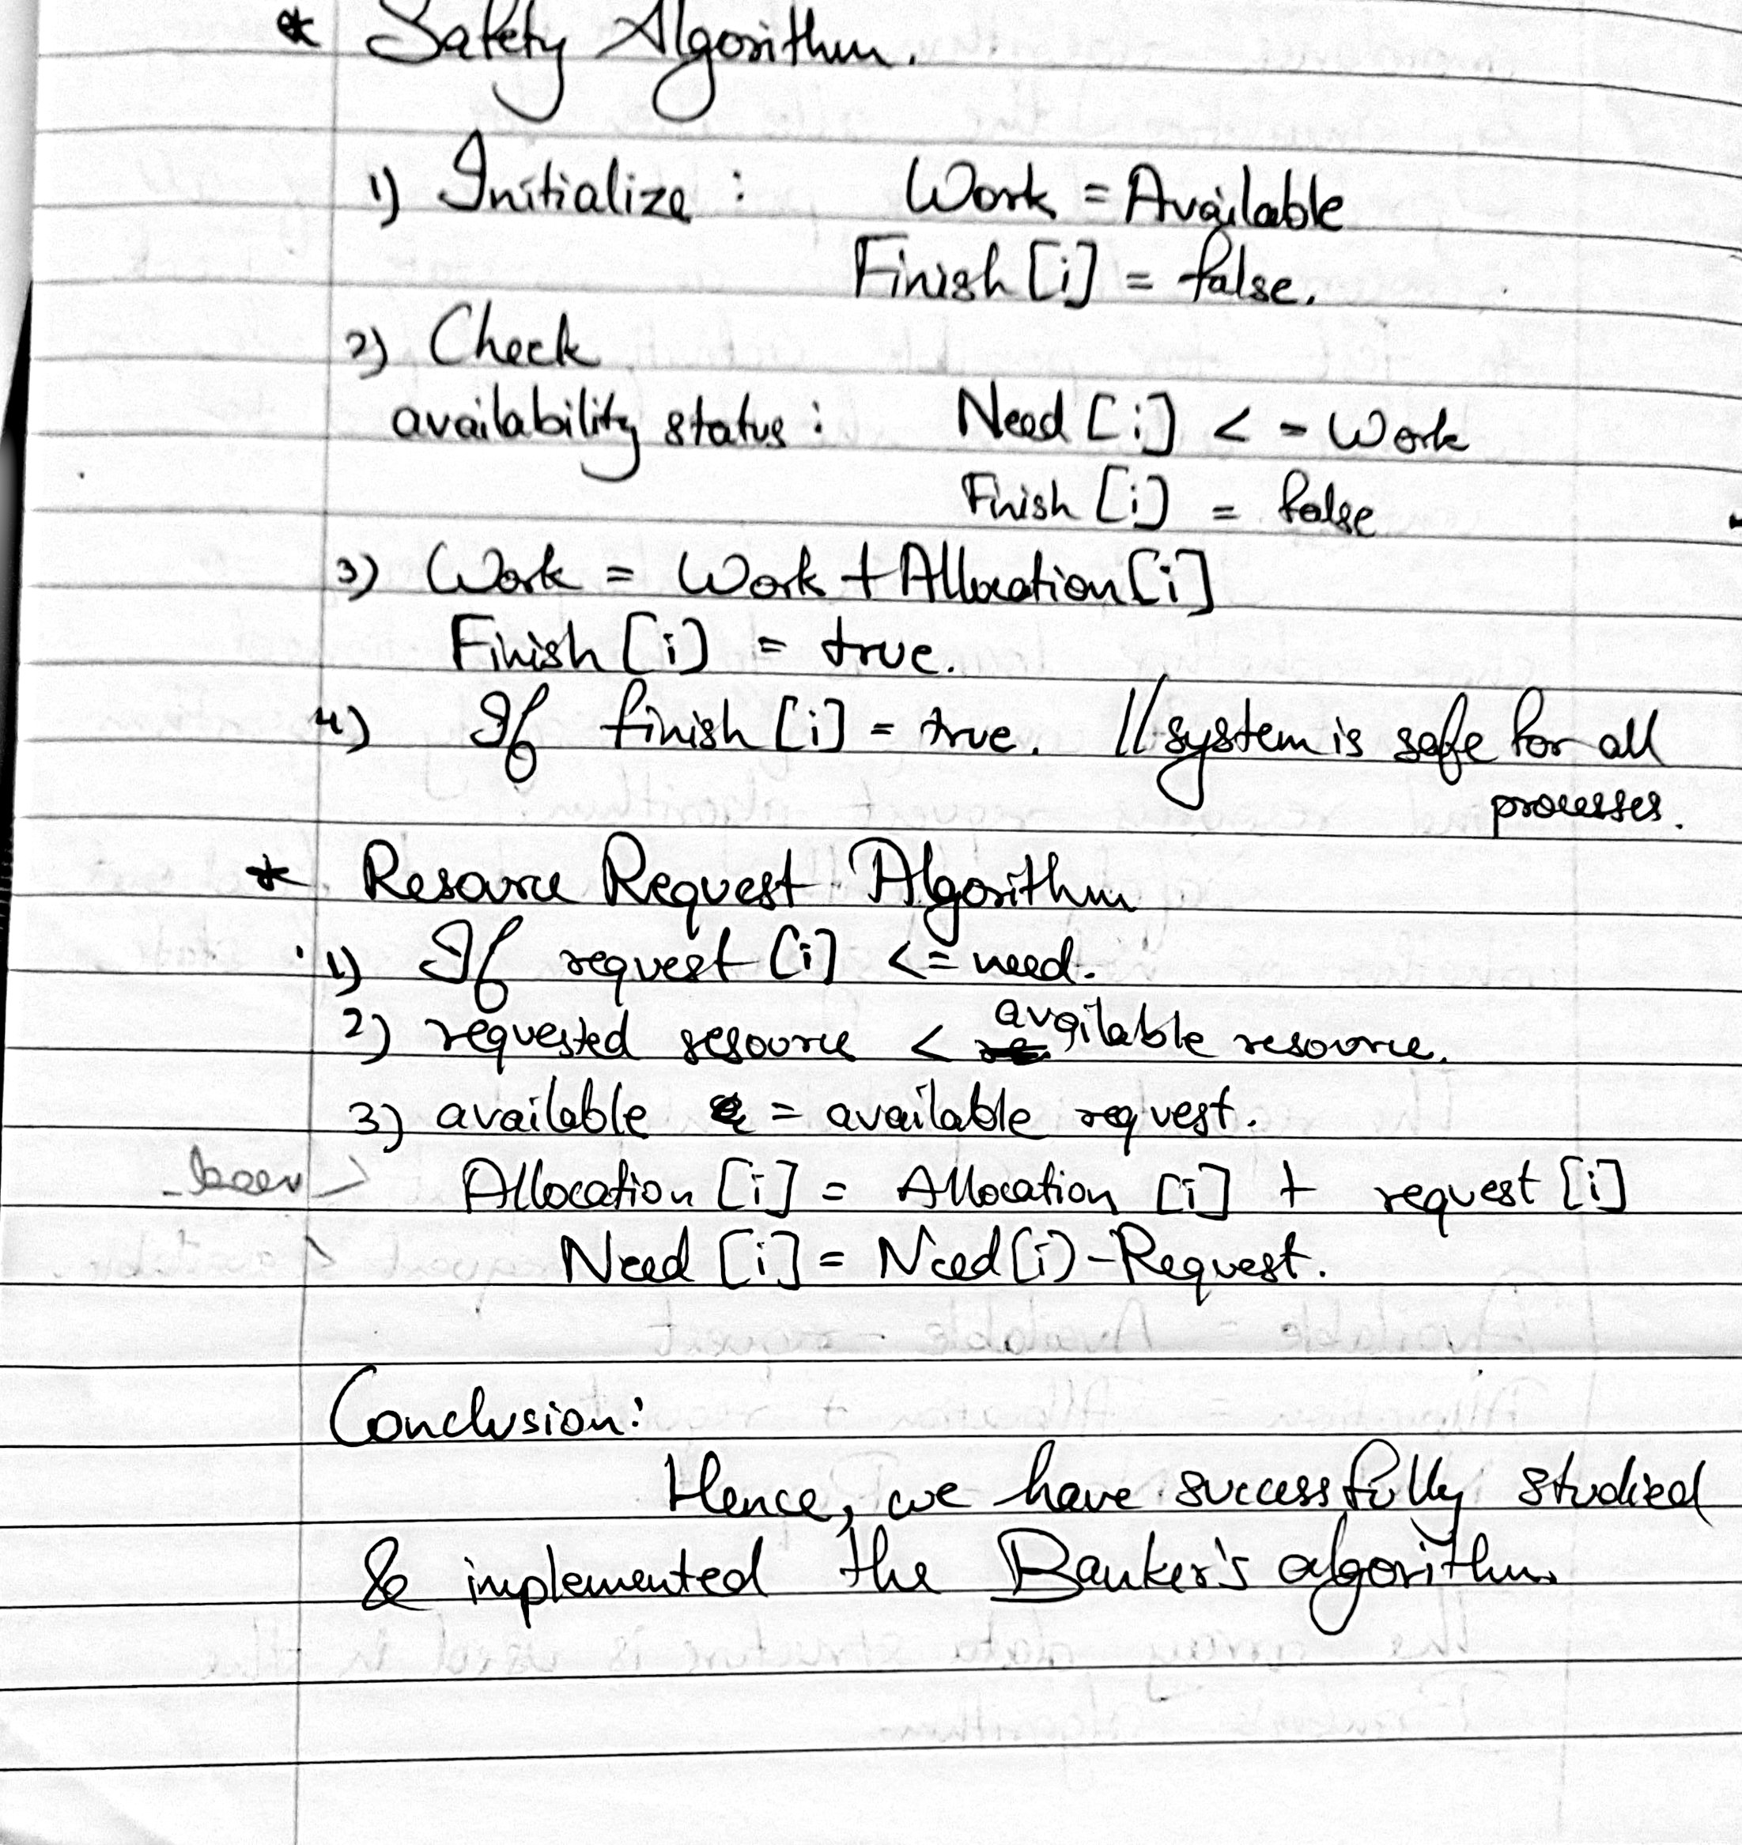

**___________________________________________________**

**Theory:**

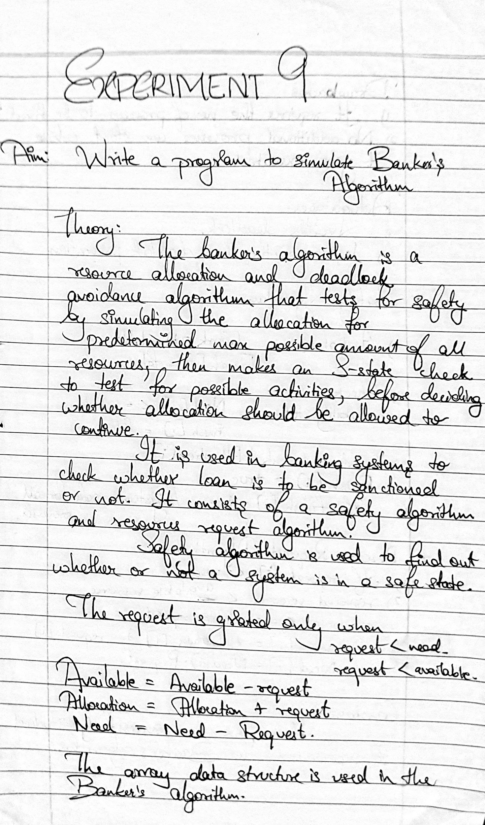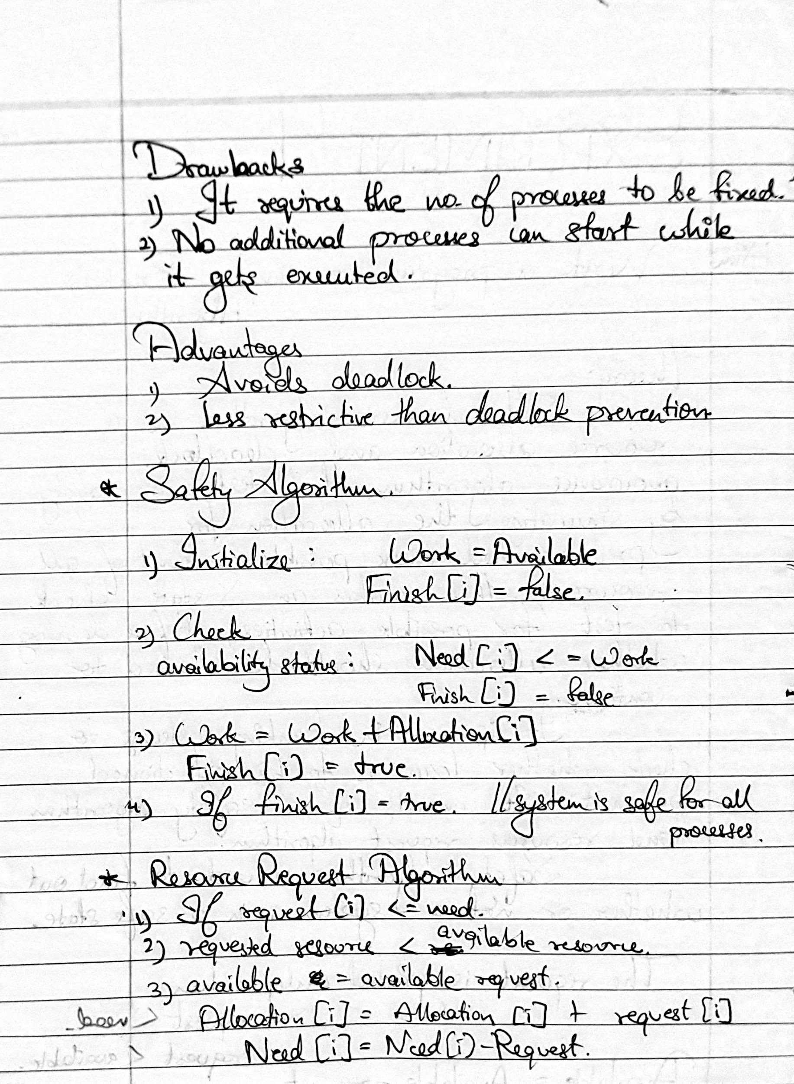

**___________________________________________________**

**Code:**

